A conversation with Diane Les Becquets

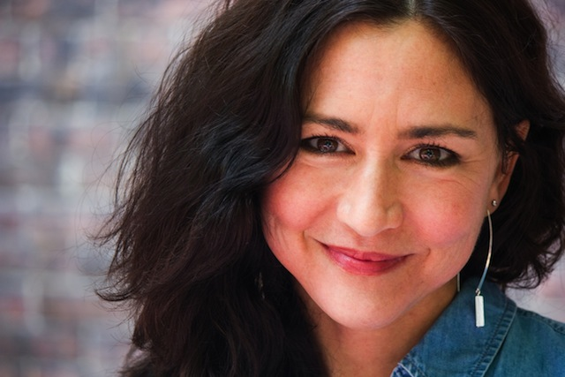

Author of THE LAST WOMAN IN THE FOREST

How do you describe THE LAST WOMAN IN THE FOREST? What inspired you to write this story?

What would it feel like to find the love of your life, to grieve his tragic and untimely death, and yet to wonder if he might have been a serial killer, and worse yet, might you have been his next victim?

My inspiration for this novel came to me about ten years ago. I’d begun dating Shaun, a forester who told me about the Connecticut River Valley killer who had murdered at least six women during the nineteen eighties, along the corridor of the Vermont and New Hampshire border. The killer was never apprehended. Having moved to New Hampshire from Colorado, I was unfamiliar with these murders. A little over a year into my relationship with Shaun, he was diagnosed with terminal brain cancer. He and I married, and eventually hired a young home health care worker. One day, I asked the home health care worker if he had any siblings, and he told me that his sister had been one of the Connecticut River victims. It was after Shaun’s death that I felt compelled by these murders and the stories of these young women's lives. I began to imagine a novel with a similar premise, but one that would take place in some of the most untamed wilderness of our country.
How much of the book is informed by your own experiences?

There are four chapters in this novel that are written from the different points of view of the victims. The reader learns that with each case, the perpetrator gained his victim’s trust before taking her life. These chapters were informed by my own narrow escape from death when I was eighteen and assaulted in a filthy trailer for twelve hours at knife point. One of the four victim chapters loosely resembles that experience. In my situation the man who assaulted me had implied that he would harm my mother. By the time I finally came forward, my family was advised by legal counsel that I should not press charges, that the ordeal would destroy me. That decision, along with the assault, continued to haunt me. Years later I asked a detective to see if he could locate the man who had assaulted me. He was unsuccessful in his search.

The final act that really freed me up to write this novel happened a few months before my debut novel, BREAKING WILD, was released. Berkley's marketing team advised me to set up a separate author Facebook page. The next day I ran a search on the man who'd assaulted me. He had changed the spelling of his last name. Images of him appeared, along with blog postings and articles. On the thirty-first anniversary of the night he'd assaulted me, he shot his wife, who was thirty years younger than he, and then himself, in front of neighbors.

Is the character of the forensic profiler Nick Shepard based on a real-life profiler and if so, how did you find him?

Nick Shepard is based on real-life criminal profiler John Philpin, who assisted law enforcement on the Connecticut River Valley cases. John is one of our nation’s first independent criminal profilers, and has worked on well-known murder cases, including the killing of JonBenet Ramsey and the Gainesville, Florida, murders. He’s the author of eight books, both fiction and nonfiction, has been a commentator for various television shows, and even served as a consultant for the TV series Dexter. Though supposedly retired now, and living in Vermont, he continues to get pulled in to work on cold cases.

After paying a fee to an online service, I obtained John’s telephone number and left him a message. People contact John all the time about one case or another (two hundred plus victims over thirty years). “So, Diane with the last name I can’t spell calls. When I figure out how to spell it, I run a background check. I was impressed. You knew what you wanted; you had a clearly defined goal; you had your own personal mission. Of course I’d talk with you. And I enjoyed it,” he wrote in one of our now hundreds of email correspondences.

Very simply, a rewarding friendship developed, and John has been an invaluable resource on this book. When deciding upon the character of Nick Shepard, it was John’s voice I heard, his personality I wished to capture. John supported my decision to model the character after him.

Your book paints a rich portrait of the outdoors – a character in and of itself – as well as pinpointing how fragile our ecosystem is. How do you create such an absorbing tapestry?

I wanted the wilderness settings in the book to be a metaphor for the interior geography of the novel’s characters. And just as fragile as our natural ecosystem is, so is the mind. There are tipping points. I spent time alone in as many of the settings as I could, hiking and camping and exploring the mountains and forests. For example, I’d been imagining the grizzly bear as a metaphor for the killer in the novel. Through my research, I learned that the highest population of grizzly bears in the contiguous U.S is in northwestern Montana. I gathered my backpacking gear, purchased a plane ticket, and was on my way to Montana.

Dogs play an important role in this novel. What type of experience do you have in the type of scent detection and training that the conservation team does with these dogs?

I’d learned of the use of scent detection dogs in wildlife conservation from a former wildlife biologist who’d worked as a dog handler, and who was an MFA student at a program where I was teaching. I immediately became fascinated. The student provided me with all kinds of articles and contacts, specifically the coordinator for Conservation Canines, part of the University of Washington’s Center for Conservation Biology, where the science and practice of scent detection dogs in wildlife study began. I conducted in depth phone interviews with the coordinator; spent a couple of days in Bozeman, Montana, where I interviewed another conservation dog group and observed the training of detection dogs; drove across the Idaho Panhandle to the Selkirk Mountains of northeastern Washington (which became one of the settings in the book), where I stayed with three young female dog handlers who were on an assignment to study the impact wolves were having on deer, elk, and the endangered woodland caribou. (As I wrote this novel, there were only 12 remaining woodland caribou in the lower 48 states.) The handlers at Conservation Canine work with shelter dogs who have been adopted and trained to detect the scat (feces) of target species in all kinds of wilderness settings.

Who was the hardest character in the book to write? The easiest?

The hardest character for me to write was my female protagonist, Marian Engström. I wanted to capture her youth and vulnerability, her innocence, as well as her adventurous nature and indomitable spirit. I needed her to be young, but not too young; trusting, but also wise and capable of tremendous growth and courage. I didn’t want her to be my younger self. I wanted her to be distinct in her own right. One of the ways I did that was to
make her a biology major, a scientist with more of an analytical mindset in the way that she processes information.

The easiest character for me to write was the criminal profiler, Nick Shepard. John Philpin provided so much inspiration for that character.

What message do you want to convey to readers about trusting their own intuition? How does gender make this harder?

The solitude men can enjoy is not something women can take advantage of with the same ease. According to John Philpin, 95 percent of all stranger to stranger homicides are committed by men against women. “Women’s gender is stacked against them; they have a target on their backs.” And too often women are afraid to trust their intuition, afraid to appear rude or crazy. “Too many women have been silenced in the name of niceness,” writes Terry Tempest Williams in her intro to Land of Little Rain by Mary Austen.

What do you think readers will take away after reading THE LAST WOMAN IN THE FOREST?

Marian, the protagonist, is relentless in her pursuit to understand the mind of her late boyfriend, and ventures into terrifying territory, physically and psychologically. I hope this novel will encourage readers to pay attention when something doesn’t feel right, to trust that small voice inside themselves, and to find the courage they need to reach out for support. And I hope the novel will give readers a new understanding into scent detection dogs and their handlers, and the important work they do in our ever fragile ecosystem.

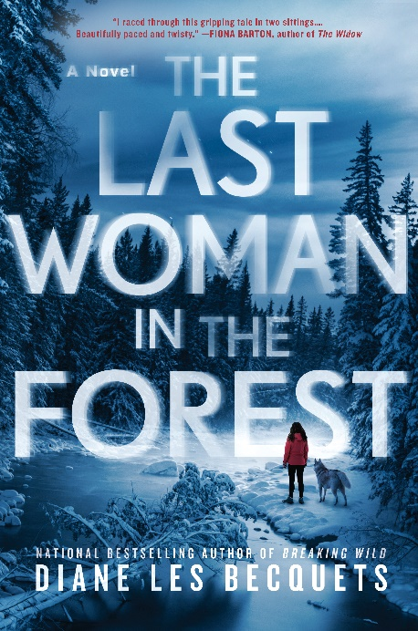

THE LAST WOMAN IN THE FOREST
By Diane Les Becquets
Berkley Hardcover
March 5, 2019

